**SIGN UP**

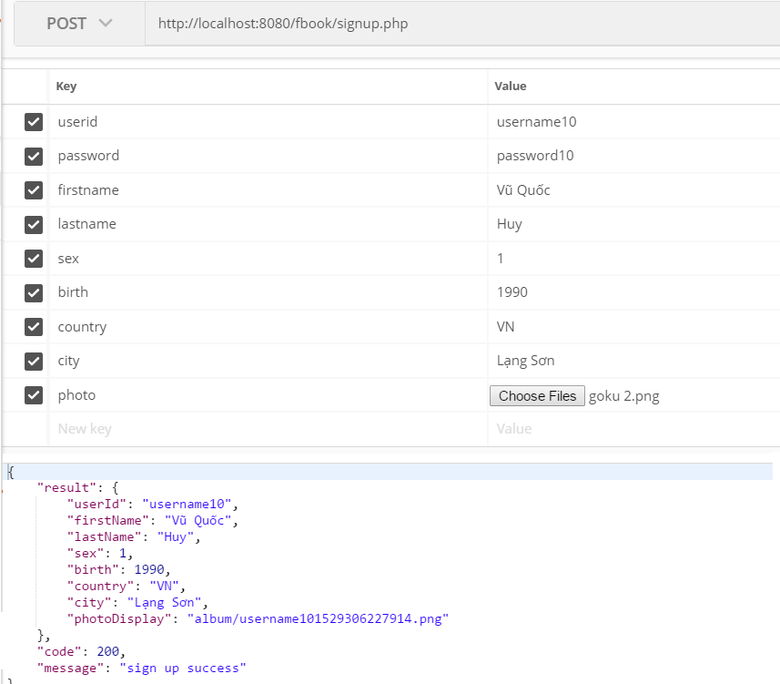

HTTP Res: **POST**

Paramester: **userid:** username to authenticate user account, unique and must be 6 to 24 characters, ascii–latin-general (a-z, A-Z, 0-1) no space char and specify char.

**password:** password to authenticate user account, unique and must be 6 to 24 characters, utf8.

**firstname:** firstname parameter must be 1 to 24 characters, utf8 and none specify char.

**lastname:** lastname parameter must be 1 to 24 characters, utf8 and none specify char.

**sex:** sex parameter must be interger value in 0 to 4. **0**:straight woman, **1**:straight man, **2:**gay, **3**:lesbian, **4**:unisex.

**birth:** birth parameter must be interger value in 1950 to (current year - 6).

**country:** country parameter must be upper char 2alpha2code as VN, EN, US, JP…

**city** : string value and candidate nullable.

**photo** : image.* (png, jpeg, jpg, bmp, gif) < 6mb and candidate nullable.

Result Callback:

Sign up Success Code: Result:

**200** user profile

Sign in Failed Code: Result:

**999** failed

**801** username has been used

Error Code: Description:

**101** required parameters is missing.

**102** required parameters is invalid.

**802** username invalid.

**803** password invalid.

**804** firstname invalid.

**805** lastname invalid.

**806** sex invalid.

**807** birth invalid.

**808** counrtry invalid.

**701** image upload failed.